The Niuhi Shark Saga Trilogy

Series Overview

Set in contemporary Hawaii, the Niuhi Shark Saga is a young adult magic realism trilogy appropriate for grades 5 and up. It tells the story of Zader (Alexander Kaonakai Westin) and his ‘ohana.
In a world where Pacific myths and legends come to life, fans of Disney’s Moana and Lilo & Stitch, The Karate Kid, and the Percy Jackson series will love The Niuhi Shark Saga Trilogy. Told in standard American English, but sprinkled with Hawaiian Pidgin English and Hawaiian in the dialogue, the series paints a vibrant picture of island life where legend and tradition are as much a part of life as eating and drinking.
The Niuhi Shark Saga is published by Makena Press. Books are available in hardback, trade paperback, and eBook from AMAZON, BARNES & NOBLE, and other national and international book stores. Each book contains a discussion guide and glossary. Free classroom materials are available for downloading on www.NiuhiSharkSaga.com

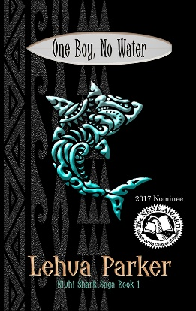
ONE BOY, NO WATER

I’m doomed.
I’m Zader, the one who sits at the beach pavilion while my brother Jay surfs. It’s not enough that I’m the weird kid allergic to water. I’m the favorite punching bag of the Blalahs, a couple of mouth breathers who terrorize me simply because they can. Being adopted by the Westins made me part of their ‘ohana, but it didn’t make me normal, no matter how hard Jay fights for me.
When Jay and my friend Char Siu go to prestigious Ridgemont Academy next year, I’ll be suffering at Lauele High School. Uncle Kahana is teaching me Lua so I can defend myself, but the Blalahs are determined to catch me when Jay’s not around.
Everybody loves Jay. Me, too. Sometimes I wish I could be him.
But that’s not the worst of it.
In the middle of the night, I dream. There’s a mysterious girl who lives in a magical place and acts like she knows me better than I know myself. We hide from the Man with Too Many Teeth. Some nights I wake up with my heart pounding in my chest and the urge to eat raw meat.
It’s just a dream, right?
But then I saw him, the Man with Too Many Teeth, walking along the reef at Piko Point.
Not even Jay can protect me now.
One Boy, No Water
284 pages
ISBN-13: 978-1535411875
ISBN-10: 1535411872
ASIN: B01IWR66MS

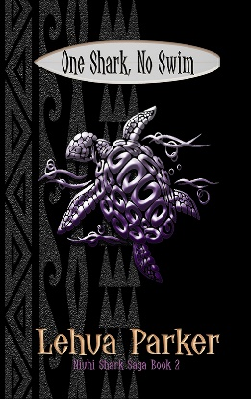
ONE SHARK, NO SWIM

It worked.
Jay’s no longer afraid of sharks. In the fall, I’m headed to Ridgemont Academy with Jay and Char Sui for our freshman year. The Blalahs have moved on to new targets. Even my water allergy is under control.
Life’s great, right?
Nope.
I can’t stop thinking about all the questions. How did imaginary Dream Girl’s lei end up in my bed? Who are my birth parents? Are they the ones leaving me strange and expensive gifts on my birthday? Who is the Man with Too Many Teeth, and why is he stalking me?
My dreams are nightmares. I don’t dare fall asleep.
People are lying to me, but I don’t know why. Uncle Kahana doesn’t trust me anymore. He’s training Jay and Char Siu to fight without me. Guro Hari’s supposed to be teaching me Filipino knife fighting, but I’m too scared to come out of the bathroom. Blades are sharp. I’d rather learn Lua and fight in the surf like Jay and Char Siu, but Uncle Kahana won’t let us share what we’re learning. He says it’s for our own safety, but I don’t believe him.
And then there’s Uncle Kahana’s Niuhi stories, Hawaiian myths about sharks in human form. If he’s right, even out of the water, no one’s safe.
I have a knife I call Shark Tooth.
I may have to use it.
That thought excites me.
And that’s the scariest thing of all.

One Shark, No Swim
314 pages
ISBN-13: 978-1535413404
ISBN-10: 1535413409
ASIN: B01IWTCYQS

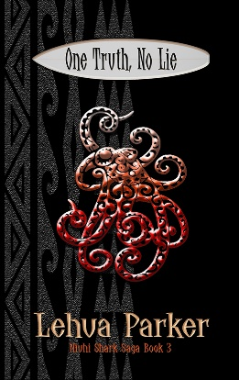
ONE TRUTH, NO LIE

I jumped.
When the ocean wrapped its arms around me, things were never going to be the same. I knew that. But I didn’t know the cost.
Kalei, The Man with Too Many Teeth, gave me an ultimatum. Bite Jay or watch as he murders everyone I love. Kalei will do it. I have no doubt.
Either way I end up alone.
Jay’s anger is going to be white-hot. Without his leg, he’ll never surf again. He’s my brother, but he’ll hunt me down and kill me for this. I know better than to think he’ll ever forgive me.
No matter what they say, I’m not Niuhi. I’m a Westin. I’m a kid. I go to high school and draw pictures and create art. Sharks are creatures of the sea. How can I live without Jay, Char Siu, Uncle Kahana, or Ilima in my life? Just me and my psycho sister Maka roaming the seas forever? No thanks.
There’s got to be more to my life than this. I refuse to believe that I’m destined to be a pawn in someone’s cosmic game.
I’m making my own rules now.
One Truth, No Lie
302 pages
ISBN-13: 978-1535413558
ISBN-10: 1535413557
ASIN: B01IWVBL8I

LEHUA PARKER is an award-winning and best-selling author of Pacific literature stories that explore the intersections of Hawaii’s past, present, and future. Her published works include the Niuhi Shark Saga Trilogy, Lauele Town Stories, and Fairy Take Ink’s Fractured series, along with various plays, poetry, short stories, and essays. Her work is used in public and private school curricula at the elementary to university level. One Boy, No Water, Book 1 in the Niuhi Shark Saga, was a 2017 Hawaii Children’s Choice Nene Award Nominee.

Originally from Hawaii and a graduate of The Kamehameha Schools, Lehua is an author, book doctor, public speaker, and educator. Trained in literary criticism and an advocate of indigenous cultural narratives, she is a frequent speaker at conferences and symposiums.

Website & Blog: www.LehuaParker.com | Email: Lehua@LehuaParker.com
Series Website: www.NiuhiSharkSaga.com | Twitter: @LehuaParker
Facebook: https://www.facebook.com/LehuaParker/ | Amazon link: http://goo.gl/PY09lQ
Instagram: @LehuaParker | Barnes & Noble link: http://goo.gl/TjE0vL

