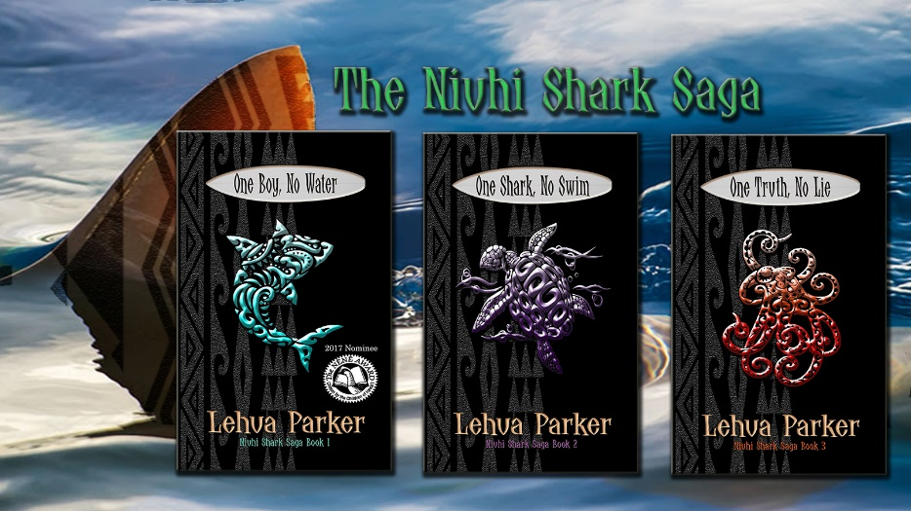
For a limited time, get the eBook of
ONE BOY, NO WATER for free:

https://dl.bookfunnel.com/uvjip1na8z

All books are available as eBooks and paperbacks from Amazon.com and Basically Books, Hilo

The Niuhi Shark Saga
Book 1: One Boy, No Water
Book 2: One Shark, No Swim
Book 3: One Truth, No Lie

Thirteen-year-old Zader Kaonakai Westin is living in his hanai brother Jay’s shadow. Jay Kapono Westin is popular—a good student and a surfing star, almost guaranteed a spot at prestigious Ridgemont Academy next year. Zader, on the other hand, is the weird kid allergic to water who sits above the beach and sketches all day.

A favorite target of the Blalahs, Zader relies on Jay to keep him safe. But Zader has secrets, like the frightening Man with Too Many Teeth and his friendship with Dream Girl, a mysterious girl who haunts his nights. Uncle Kahana seems to know more about Zader’s past than he’s sharing, especially about his water allergy and inability to eat rare meat or seafood.

When Jay has a shark scare that keeps him out of the ocean, things are set in motion that forever change their destiny. It’s going to push Zader, Jay, and their friend Char Siu beyond their limits to solve the Niuhi Shark Saga.

In a world where Pacific myths and legends come to life, fans of Disney’s Moana and Lilo & Stitch , The Karate Kid, and the Percy Jackson series will love The Niuhi Shark Saga trilogy.
_____________________________________________________________________________________

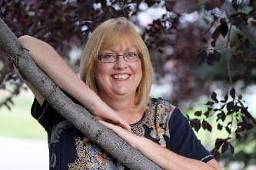
LEHUA PARKER is an award-winning and best-selling author of Pacific literature stories that explore the intersections of Hawaii’s past, present, and future. Her published works include The Niuhi Shark Saga Trilogy and Lauele Town Stories, along with various plays, poetry, short stories, and essays. A founding member of Fairy Tale Ink, her novellas also appear in the Fractured Fairy Tales collections.

Her work is featured in public and private school curricula at the elementary to university level. One Boy, No Water, Book 1 in The Niuhi Shark Saga, was a 2017 Hawaii Children’s Choice Nene Award Nominee.

Originally from Hawaii and a graduate of The Kamehameha Schools, Lehua is an author, book doctor, public speaker, and educator. Trained in literary criticism and an advocate of indigenous cultural narratives, she is a frequent presenter at conferences, symposiums, and schools.

Connect and talk story with her at:
Websites: www.LehuaParker.com and www.NiuhiSharkSaga.com
email: AuntyLehua@LehuaParker.com
Facebook: Lehua Parker
Instagram: LehuaParker

